Morphological, molecular, and biological characterization of Monalonion dissimulatum Distant associated with cacao in Amazonas, Peru
Santos T. Leiva-Espinoza^{1,2*}, Henry W. Santillan-Culquimboz¹, Gian F. Rabanal-Díaz³, Jhon Anthony Vergara-Copacondori³, Vilma Aguilar-Rafael¹, Luis Alberto Cubas-Vasquez¹, Duber Banda-Martinez¹, Einstein R. Reyna-Rivera¹
¹Instituto de Investigación para el Desarrollo Sustentable de Ceja de Selva (INDES-CES), Universidad Nacional Toribio Rodríguez de Mendoza de Amazonas, 342 Higos Urco, Chachapoyas 01001, Perú
²Grupo de Investigación en procesos en Sanidad Vegetal - Instituto de Investigación para el Desarrollo Sustentable de Ceja de Selva (INDES-CES), Universidad Nacional Toribio Rodríguez de Mendoza de Amazonas, 342 Higos Urco, Chachapoyas 01001, Perú
³Universidad Nacional de Cajamarca, Facultad de Ciencias Agrarias, Departamento Académico de Agronomía, Cajamarca, Perú.
*Corresponding author: Santos T. Leiva-Espinoza
E-mail: santos.leiva@untrm.edu.pe

Author | ORCID | email
Santos T. Leiva-Espinoza | 0000-0003-1710-1994 | santos.leiva@untrm.edu.pe
Henry W. Santillan-Culquimboz | 0000-0002-7384-0372 | henry.santillan@untrm.edu.pe
Gian F. Rabanal-Díaz | 0000-0001-5287-0698 | grabanald15@unc.edu.pe
Jhon Anthony Vergara-Copacondori | 0000-0002-8583-4404 | javergara@unc.edu.pe
Vilma Aguilar-Rafael | 0000-0001-6797-0093 | vilma.aguilar.epg@untrm.edu.pe
Luis Alberto Cubas-Vasquez | 0009-0008-1354-2016 | 7343142221@untrm.edu.pe
Duber Banda-Martinez | 0009-0003-6100-6545 | duber.banda.epg@untrm.edu.pe
Einstein R. Reyna-Rivera | 0009-0002-7615-1123 | 7485589391@untrm.edu.pe

ABSTRACT
Monalonion dissimulatum Distant is a pest associated with cacao in Peru; however, information on its identification, incidence, and biology remains limited. This study provides an integrated characterization of the species through the assessment of field damage and incidence, morphological characterization of immature stages and adults, molecular analysis based on the COI gene, and monitoring of its life cycle. Twenty-five cacao plots distributed between 430 and 1,155 m a.s.l. were evaluated, and the relationship between incidence and elevation was analyzed using Pearson correlation and linear regression. Damage was characterized by necrotic lesions that progressed into coalescent, crust-like areas on the pericarp, accompanied by deformation and desiccation in severely affected fruits. Incidence ranged from 12 to 75% and was positively correlated with elevation (r = 0.62; p < 0.001; R² = 0.385), although this variable explained only part of the observed variability. Morphological characterization of nymphs and adults revealed characters consistent with Monalonion dissimulatum. As complementary evidence, the three COI sequences generated in this study showed 100% identity with a reference sequence of Monalonion dissimulatum in BOLD and clustered with the species in the phylogenetic analysis. The life cycle comprised the egg stage, five nymphal instars, and the adult stage, with a total duration of 34–46 days under field conditions. By integrating data on damage, incidence, morphology, molecular identification, and biological development, this study expands the reference information available for the recognition and monitoring of Monalonion dissimulatum in cacao production systems.
Keywords: Miridae, Monaloniini; integrative taxonomy; morphometrics; DNA barcoding

INTRODUCTION
Cacao (Theobroma cacao L.) is a tropical crop of high socioeconomic importance and constitutes the main raw material for the global chocolate industry (Kongor et al. 2024). Its production provides income and livelihoods for approximately 40–50 million people worldwide (Beg et al. 2017; Kongor et al. 2024) and depends largely on smallholder farmers, who are responsible for 80–90% of global production (Beg et al. 2017). However, these producers often face limitations in technical assistance, investment capacity, and access to technologies, which hinder the implementation of effective management practices against pests and diseases, considered among the main constraints on cacao productivity and sustainability (Marelli et al. 2019; Hernández-Núñez et al. 2020; Tan et al. 2025).
In the Neotropics, the genus Monalonion Herrich-Schaeffer (Hemiptera: Miridae: Bryocorinae: Monaloniini) comprises phytophagous species of economic importance associated with various crops (Gamboa et al. 2020). Among them, Monalonion dissimulatum Distant is an important pest in cacao plantations: nymphs and adults feed on shoots, young stems, and pods, causing particularly severe damage to the fruit (Vargas Serna et al. 2020; Gamboa et al. 2024). During feeding, punctures produced by the mouthparts cause lesions that may lead to necrosis of the affected tissues (Vargas Serna et al. 2020). In young pods, feeding damage may cause deformation, hardening, and death, whereas in more developed pods, deformation and smaller seeds have been reported(Gamboa et al. 2024). The presence and abundance of M. dissimulatum in cacao plantations have been associated with light and shading conditions within the crop (Hernández-Núñez et al. 2020). In addition, variation in its abundance has been observed among areas located at different elevations and under different light-exposure conditions (Gutierrez Soto and Sánchez Castillo 2024), suggesting that the species’ response may be associated with environmental conditions that vary along elevational gradients.
Despite its phytosanitary importance, the tools currently available for the identification and delimitation of M. dissimulatum remain insufficient for reliable taxonomic determination (Gamboa et al. 2020). The taxonomic revision of the genus dates back to Carvalho (1972), who provided a key to 11 species based primarily on coloration characters and measurements of different body structures. Subsequent studies by (Carvalho 1984, 1985a, b, 1988; Carvalho and Costa 1988) expanded and modified the taxonomic knowledge of the genus through new species descriptions and nomenclatural changes, ultimately leading to the 16 species currently recognized (Gamboa et al. 2020). Nevertheless, problems persist in the delimitation of some taxa, partly because of the historical emphasis placed on coloration characters that exhibit intraspecific variability (Gamboa et al. 2020; Noboa et al. 2024). These limitations highlight the need to integrate morphological characterization with complementary molecular evidence. In this context, the mitochondrial cytochrome c oxidase subunit I (COI) marker has begun to be used as a complement to morphological identification in Monalonion (Noboa et al. 2024; Leiva-Espinoza et al. 2026).
In addition to the taxonomic limitations, available information on the biology of M. dissimulatum remains scarce. The species exhibits paurometabolous development, comprising the egg stage, five nymphal instars, and the adult stage (Vargas Serna et al. 2020). Available information on its biological development derives mainly from observations conducted under specific environmental conditions and in particular localities (Huaycho Callisaya et al. 2017; Vargas Serna et al. 2020), which limits its direct extrapolation to other cacao-producing regions. Characterizing the developmental stages and the duration of the life cycle under local conditions is therefore relevant for expanding knowledge of the species and generating reference information for its monitoring and management.
Although M. dissimulatum has previously been recorded in Peru (Gamboa et al. 2020; Vargas Serna et al. 2020), the available knowledge on this species remains limited and fragmented across taxonomic, biological, and ecological studies. This fragmented body of knowledge limits an integrated understanding of its identity, incidence, damage, and biological development in cacao production systems. Therefore, the general objective of this study was to characterize M. dissimulatum associated with cacao cultivation in Amazonas, Peru. To this end, the following specific objectives were established: (i) to evaluate the incidence and damage caused by M. dissimulatum in cacao plantations in Amazonas, Peru, and determine their relationship with elevation; (ii) to morphologically characterize the developmental stages of M. dissimulatum associated with cacao cultivation; (iii) to complement the identification through analysis of the mitochondrial cytochrome c oxidase subunit I (COI) marker; and (iv) to determine the duration of the developmental stages of M. dissimulatum under the local conditions of the study.

MATERIALS AND METHODS

Study area
The study was conducted in 25 cacao-producing plots of Theobroma cacao L., each approximately 1 ha in area, located in the provinces of Bagua and Utcubamba, Amazonas Region, Peru, at elevations ranging from 430 to 1,155 m a.s.l. (Figure 1). The plots were distributed across the districts of Cajaruro, El Milagro, Aramango, Imaza, Bagua, Copallín, and La Peca. Field evaluations were conducted between February and May 2025.
The incidence and damage associated with M. dissimulatum were evaluated in all plots. The life cycle was studied in situ in a plot located in the district of Cajaruro, whereas specimens used for morphological and molecular characterization were collected from three plots located in the districts of Cajaruro and La Peca. Samples were processed at the Plant Health Laboratory of the Universidad Nacional Toribio Rodríguez de Mendoza de Amazonas.
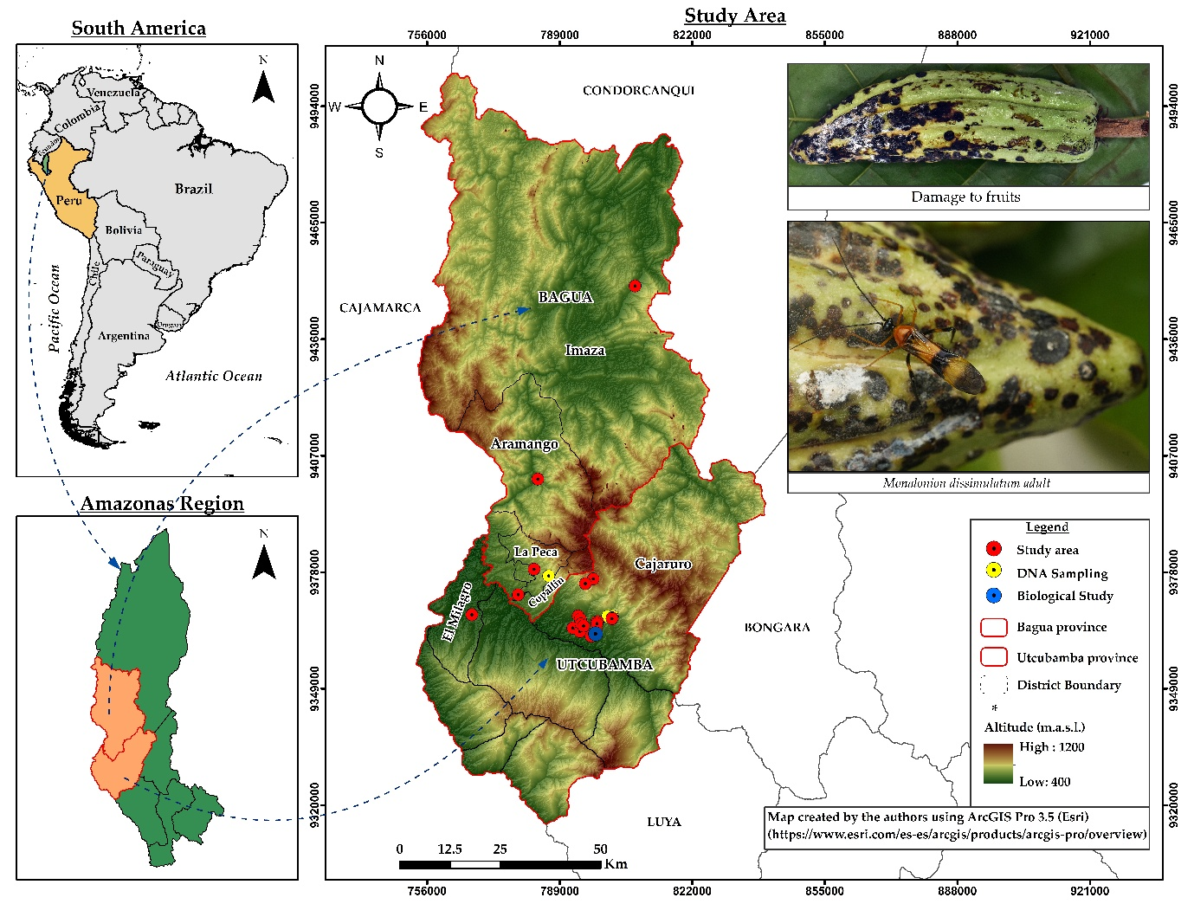
Figure 1. Location and spatial distribution of the cacao plots evaluated for M. dissimulatum in the provinces of Bagua and Utcubamba, Amazonas Region, Peru, distributed between 430 and 1,155 m a.s.l. The points represent the plots considered for the assessment of incidence and damage, yellow points indicate the specimen collection sites for molecular characterization, and the blue point corresponds to the site where the biological study was conducted. The insets show the characteristic damage caused by M. dissimulatum on cacao fruits and an adult of the species. Topographic data were derived from the ASTER Global Digital Elevation Model (GDEM), 30 m resolution, provided by NASA and downloaded from NASA Earthdata Search (https://search.earthdata.nasa.gov/). Peru’s administrative boundaries were obtained from the Instituto Geográfico Nacional (https://www.idep.gob.pe/).

Plot selection criteria
The plots were selected using stratified sampling according to three elevational zones representative of cacao-producing areas: low (≤600 m a.s.l.), intermediate (>600–900 m a.s.l.), and high (>900 m a.s.l.). Within each stratum, plots were randomly selected from the available production units whose owners authorized the evaluations.
Cacao was grown in agroforestry systems shaded primarily by forest tree species, including Cordia alliodora, Cedrela odorata, and Calycophyllum spruceanum. These agroforestry systems had been established 15–25 years earlier and were predominantly planted with native cacao, with scattered occurrences of the CCN-51 clone.
Planting density was 3 × 3 m (1,111 plants ha⁻¹). The plots were managed using traditional practices, mainly weed control and light pruning, and received no fertilizer applications during the evaluation period.

Damage identification and incidence assessment
Damage to cacao pods was identified through direct field observation and qualitative assessment. The presence of feeding puncture marks or circular lesions at feeding sites, changes in coloration, localized tissue depression, formation of crusts or suberized tissue, deformation of young fruits, and coalescence of lesions were considered indicators of damage. The presence of nymphs or adults of M. dissimulatum on the pods was considered additional evidence of feeding activity, but was not required for damage identification. The assessment criteria were established based on previously reported descriptions and methodologies (Vargas et al. 2005; Huaycho Callisaya et al. 2017; Hernández-Núñez et al. 2020).
The incidence of M. dissimulatum was estimated at the plant level. In each plot, 286 cacao plants were evaluated, selected along a zigzag sampling path. The sample size was calculated using the finite population formula proposed by (Cochran 1977):
$$n=\frac{N Z^{2}p q}{e^{2}\left(N-1\right)+Z^{2}p q}$$

where n is the sample size; N, the population size; Z, the critical value of the standard normal distribution for the specified confidence level; p, the expected proportion of affected plants (q = 1 − p); and e, the maximum allowable error. For N = 1,111, a 95% confidence level (Z = 1.96), e = 0.05, and maximum variability (p = q = 0.50) were used.
For each plant, the presence of nymphs or adults of M. dissimulatum, as well as damage consistent with its feeding activity, was recorded according to the criteria described above. Any plant showing at least one of these indicators was classified as affected. Incidence was calculated as the percentage of affected plants relative to the total number of plants evaluated:

$$\text{Incidence (\%)}=\frac{\text{Number of affected plants}}{\text{Total number of plants evaluated}}×100$$

Specimen collection and preservation
Monalonion specimens were collected from infested cacao pods and branches and included eggs, nymphal instars, and adults.
Egg clutches were located in the field by visual inspection of cacao pods, complemented by backlighting and examination with a hand lens, both on apparently healthy fruits and on those showing symptoms of damage. To preserve their integrity, pods containing egg clutches were placed in ventilated plastic containers and carefully secured during transport to the Plant Health Laboratory.
Nymphs were collected manually and separated according to developmental instar. Each group was placed in ventilated plastic containers with cacao leaves and fruits as plant substrate. The fruits were immobilized to minimize mechanical damage to the specimens during transport. Adults were collected manually and with an entomological net and transported under similar conditions.
In the laboratory, the developmental instar of the nymphs was verified and the sex of the adults was determined. Eggs were removed from the pods by careful dissection using a sterile scalpel. Specimens intended for morphometric analysis were preferably examined immediately after euthanasia to minimize possible alterations resulting from preservation. Subsequently, the specimens were preserved in 70% ethanol for analysis.

Morphological characterization
The specimens were examined using a Nikon SMZ18 stereomicroscope (Nikon Corp., Tokyo, Japan) equipped with a Nikon DS-Ri digital camera. Image acquisition and measurement recording were performed using NIS-Elements D software, version 5.00.00 (64-bit; Build 1223). Morphological characters were further examined by scanning electron microscopy (SEM) using a ZEISS EVO microscope operated in variable-pressure mode (Extended Pressure, 60 Pa), without metal coating of the specimens. Micrographs were obtained at an accelerating voltage of 20 kV, with the working distance (WD) adjusted according to specimen size, orientation, and surface topography. A high-definition backscattered electron detector (HDBSD) was used, with different magnification levels selected according to specimen size and the morphological characters of interest.
For adults, morphological characterization was based on the original description of M. dissimulatum(Distant 1883), the taxonomic revision by Carvalho (1972) and the morphological characters considered for the genus Monalonion by (Namyatova and Cassis 2016) and (Gamboa et al. 2020). For immature stages, the external morphology of the egg and the five nymphal instars was examined, using the available information for M. dissimulatum as a reference (Vargas Serna et al. 2020; Gamboa et al. 2024) and, as a comparative methodological reference, the description of the immature stages of M. velezangeli provided by Giraldo-Jaramillo et al. (2010). Characterization was performed on 45 specimens randomly selected for each developmental stage.

DNA extraction and amplification

Total genomic DNA was extracted from thoracic tissue of three Monalonion sp. specimens using the Quick-DNA™ Tissue/Insect Miniprep Kit (Zymo Research, USA), following the manufacturer’s instructions. DNA concentration was quantified by spectrophotometry (BioSpectrometer® kinetic, Eppendorf, Germany), and the samples were stored at −20 °C. A partial fragment of the mitochondrial cytochrome c oxidase subunit I (COI) gene was amplified by polymerase chain reaction (PCR) using the universal primers LCO1490 and HCO2198 (Folmer et al., 1994). The PCR reactions (25 µL) contained 12.5 µL of GoTaq® PCR Master Mix (1×, Promega), 1.25 µL of each primer (10 µM), 5 µL of nuclease-free water, and 5 µL of template DNA (1 ng/µL). The thermal cycling profile consisted of an initial denaturation at 94 °C for 5 min; 35 cycles of 94 °C for 30 s, 47 °C for 40 s, and 72 °C for 40 s; followed by a final extension at 72 °C for 8 min.

Sequencing and phylogenetic inference
The amplification products were verified by electrophoresis on 1% agarose gels stained with SYBR® Safe (Cleaver Scientific, United Kingdom), purified, and sequenced in both directions using the Sanger method (Macrogen, Chile). Consensus sequences were generated in Sequencher v.5.4.6 (Gene Codes Corporation, USA) after trimming low-quality ends and assembling the bidirectional reads. Molecular identification was assessed by comparing the sequences with records available in the Barcode of Life Data System (BOLD).
For phylogenetic inference, the sequences obtained were aligned with reference sequences of M. bondari (OR961531, OR961530), M. velezangeli (PQ046647), and M. dissimulatum (TRBBO262-11, BOLD). Multiple sequence alignment was performed using MUSCLE in MEGA X (Kumar et al. 2018). The phylogenetic tree was reconstructed under the maximum likelihood (ML) criterion using RAxML-HPC BlackBox through the CIPRES Science Gateway, with the GTR+G+I substitution model and 1,000 bootstrap replicates to assess nodal support. Rayieria acaciae (OP394107) was designated as the outgroup. The sequences generated in this study were deposited in GenBank under accession numbers PX954299 (LES54), PX954300 (LES58), and PX954301 (LES59).

Development and duration of the life cycle
The life cycle of M. dissimulatum was evaluated in situ on cacao plants in a productive plot within the study area. To obtain egg clutches, one adult pair (male and female) was confined in each of 10 rectangular cages (25 × 25 × 30 cm) constructed with a wooden frame and covered with tulle mesh, which were installed over selected cacao pods.
The eggs, laid endophytically in the pod tissue, were individually located and marked. Sixty eggs were selected and observed daily to determine the duration of the incubation period. After hatching, 47 viable nymphs were obtained.
Nymphal development was monitored in cages of identical dimensions, also installed over cacao pods. The nymphs were distributed among these cages and observed daily with the aid of an entomological hand lens, recording the duration of each of the five nymphal instars until adult emergence. The emerged adults were maintained under the same conditions and evaluated daily until natural death. The duration of the incubation period, each nymphal instar, the adult stage, and the total life cycle was recorded.

Statistical analysis
Statistical analyses were performed in R version 4.6.1 (R Core Team 2026). The relationship between incidence and elevation was evaluated using Pearson’s correlation and simple linear regression, with incidence (%) as the response variable and elevation (m a.s.l.) as the explanatory variable. The slope (β), its 95% confidence interval, the coefficient of determination (R²), and statistical significance (α = 0.05) were estimated from the model. Model validation included diagnostic residual plots and the Shapiro–Wilk test for normality and the Breusch–Pagan test for homoscedasticity, as well as Cook’s distance analysis to identify influential observations. Morphometric variables of nymphs and adults, as well as life-cycle duration, were analyzed descriptively using the mean, standard deviation, and range. Data processing was performed using the dplyr and tidyr packages, graphical representations were generated with ggplot2, and statistical tests were conducted using lmtest.

RESULTS

Damage and incidence of Monalonion dissimulatum
Damage caused by M. dissimulatum was observed in both native cacao and the CCN-51 clone. Symptoms were characterized by punctate lesions, initially circular and dark brown to black, located on the pericarp and associated with insect feeding sites. These lesions caused tissue depression and, as their density increased, tended to coalesce, forming irregular, crust-like necrotic areas that affected extensive portions of the fruit surface. Young fruits with high levels of damage showed deformation and irregular development, whereas more severely affected fruits exhibited extensive areas of necrosis accompanied by tissue desiccation and deterioration (Figure 2).
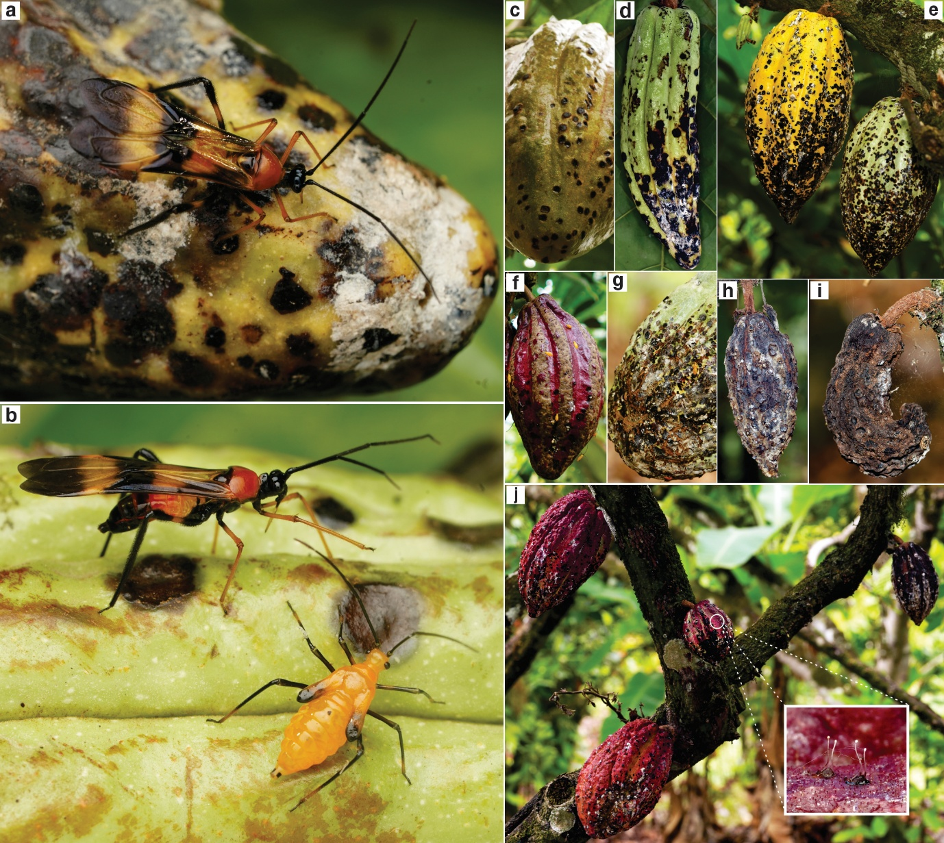
Figure 2. Damage caused by M. dissimulatum on cacao fruits. (a) Adult on a pod with extensive, coalescent necrotic lesions. (b) Adult and nymph on the pericarp, showing circular necrotic lesions and tissue depression. (c–e) Progression of damage in fruits at different developmental stages: dark brown to black punctate lesions, lesion coalescence, and fruit deformation. (f–g) Detail of coalescent lesions forming crust-like necrotic areas, with nymphs of M. dissimulatum present. (h–i) Advanced damage characterized by extensive necrosis, deformation, and tissue desiccation. (j) Affected fruits on the cacao plant; the inset shows the endophytic egg clutches of M. dissimulatum in the pericarp.
Pest incidence across the evaluated plots ranged from 12 to 75% and was positively and significantly correlated with elevation (r = 0.62; p < 0.001). The regression model explained 38.5% of the observed variability (F = 14.4; p < 0.001). The estimated slope was 0.062 percentage points per meter of elevation (95% CI: 0.028–0.096; p < 0.001), equivalent to an average increase of 6.2 percentage points in incidence for every 100 m increase in elevation (Figure 3).
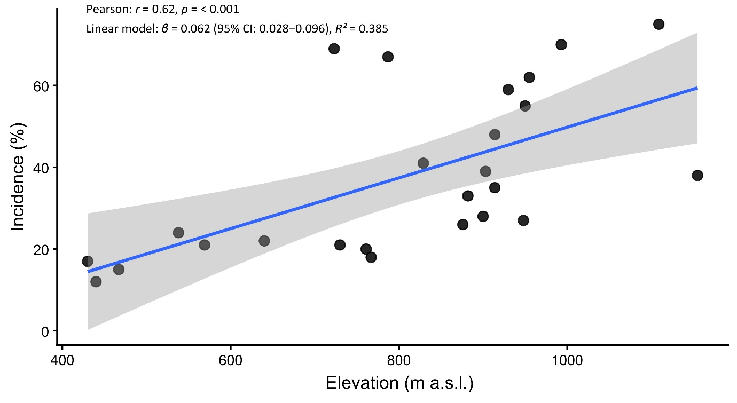
Figure 3. Relationship between the incidence of M. dissimulatum and the elevation of the evaluated plots. Points represent the observed incidence (%) in each of the 25 plots. The solid line indicates the fitted linear regression model, and the shaded area represents the 95% confidence interval. Incidence was positively correlated with elevation (r = 0.62; p < 0.001; R² = 0.385).

Taxonomy
Monalonion dissimulatum Distant, W. L. 1883. Biologia Centrali-Americana. Insecta. Rhynchota. Hemiptera-Heteroptera, Vol. 1. Taylor & Francis, London.
Monalonion dissimulatum (Miridae: Monaloniini) exhibits paurometabolous development, comprising an egg stage and five nymphal instars prior to the adult stage.
Morphology
Egg. Elongated and slightly curved, milky white to translucent in color. Oviposition is endophytic. Eggs remain embedded in the pericarp of cacao pods, with the anterior pole close to the surface. Two slender, hyaline filaments emerge from this pole, with expanded, rounded tips exposed to the external environment and associated with respiration during embryonic development (Fig. 4b–e).
Nymphs. Body predominantly yellow-orange in coloration. Antennae long and filiform, consisting of four predominantly dark antennomeres; the fourth antennomere has a pale-yellow apex and a subfusiform to fusiform shape, depending on the developmental instar. Legs elongated, with the distal portion of the tibiae paler. Abdomen with nine distinguishable segments. A glandular area with a subcordiform outline and a brown margin is located dorsally on the fourth abdominal segment, with its apex directed posteriorly. Abdominal extremity bearing a prominent terminal structure with a dark brown to black band, interrupted dorsally and ventrally. The five nymphal instars are distinguished by a progressive increase in body size, changes in the dorsal pigmentation pattern, and development of the wing pads (Figs. 4 and 5).
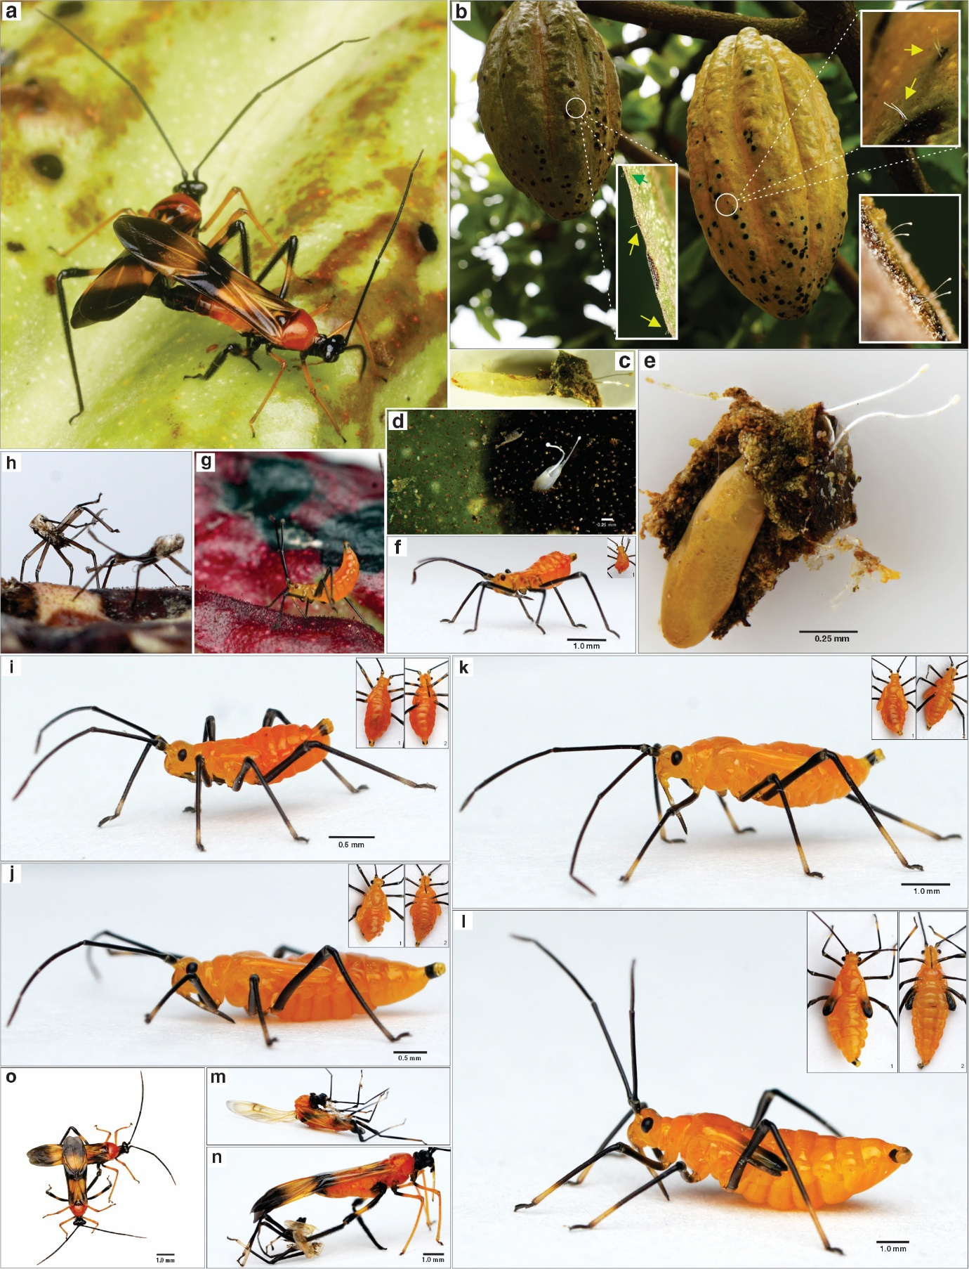
Figure 4. Reproductive aspects and developmental stages of M. dissimulatum. (a) Adults during mating. (b) Oviposition sites on the pericarp of cacao pods; the insets show the egg filaments exposed above the surface. (c) Recently laid egg. (d) Hatched egg. (e) Egg close to hatching. (f, g) First-instar nymph; in (g), the elevated position of the posterior end of the abdomen is visible. (h) Exuvia corresponding to the first nymphal instar. (i) Second-instar nymph. (j) Third-instar nymph. (k) Fourth-instar nymph. (l) Fifth-instar nymph. (m, n) Molting from the fifth nymphal instar to the adult stage. (o) Dorsal view of a female and male during mating.
Instar I. Body with a reddish longitudinal middorsal band, narrow anteriorly and widened in the middle and posterior regions, extending from the prothorax to the base of the terminal anal structure. Two reddish longitudinal dorsolateral bands extend from the first abdominal segment to the same region. Fourth antennomere subfusiform. Distal portion of the tibiae slightly paler. Posterior abdominal region elevated relative to the longitudinal axis of the body. Wing pads not externally evident (Figs. 4f and 5a–c).
Instar II. Body with a reddish longitudinal middorsal band, narrower than in instar I, tapering anteriorly and slightly widened in the middle and posterior regions, extending from the prothorax toward the terminal abdominal region. Reddish dorsolateral bands not evident. Fourth antennomere subfusiform. Distal portion of the tibiae light brown. Wing pads incipient, yellow-orange, located dorsolaterally on the mesothorax and metathorax (Figs. 4i and 5d–f).
Instar III. Body with a faint reddish longitudinal middorsal band, more evident on the mesothorax and metathorax, gradually fading toward the posterior abdomen. Fourth antennomere subfusiform. Distal portion of the tibiae light brown. Wing pads yellow-orange, conspicuous, and more developed than in instar II, extending posteriorly to cover the second abdominal segment (Figs. 4j and 5g–i).
Instar IV. Body with faint remnants of the reddish longitudinal middorsal band present in previous instars. Fourth antennomere subfusiform to fusiform. Distal third of the tibiae pale yellow. Wing pads yellow-orange, more developed than in instar III, extending posteriorly to the posterior margin of the fourth abdominal segment (Figs. 4k and 5j–l).
Instar V. Body yellow-orange, without a conspicuous middorsal band. Fourth antennomere fusiform. Distal third of the tibiae yellowish. Wing pads well developed, extending posteriorly to the posterior margin of the fourth abdominal segment, with dark brown to black pigmentation in their distal portion (Figs. 4l and 5m–o).
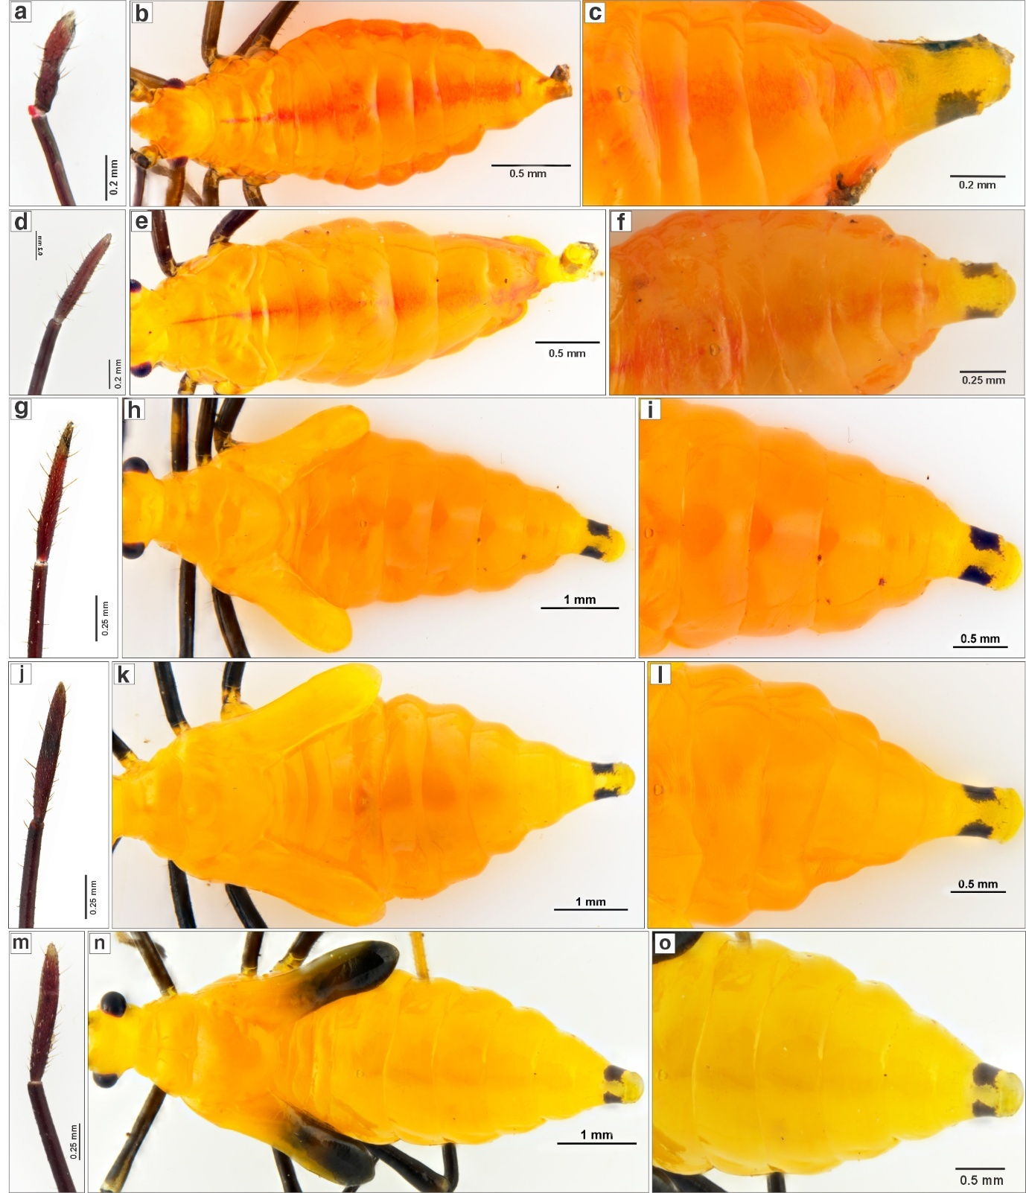
Figure 5. Morphological characters of the five nymphal instars of Monalonion dissimulatum. (a–c) Instar I: (a) Fourth antennomere; (b) dorsal view of the thorax and abdomen; (c) glandular area and terminal abdominal region. (d–f) Instar II: (d) Fourth antennomere; (e) dorsal view of the thorax and abdomen; (f) glandular area and terminal abdominal region. (g–i) Instar III: (g) Fourth antennomere; (h) dorsal view of the thorax and abdomen; (i) glandular area and terminal abdominal region. (j–l) Instar IV: (j) Fourth antennomere; (k) dorsal view of the thorax and abdomen; (l) glandular area and terminal abdominal region. (m–o) Instar V: (m) Fourth antennomere; (n) dorsal view of the thorax and abdomen; (o) glandular area and terminal abdominal region.
Morphometrics. Body length and width increased progressively: instar I (2.00 ± 0.24 × 0.88 ± 0.12 mm), instar II (3.38 ± 0.30 × 1.23 ± 0.07 mm), instar III (4.64 ± 0.33 × 1.72 ± 0.17 mm), instar IV (6.47 ± 0.40 × 2.35 ± 0.05 mm), and instar V (7.61 ± 0.25 × 2.46 ± 0.10 mm) (Table 1).
Table 1. Morphometrics of Monalonion dissimulatum nymphs
Nymphal instar | Body length (mm) | Range | Body width (mm) | Range
I | 2.00 ± 0.24 | 1.45–2.45 | 0,88 ± 0.12 | 0.59–1.09
II | 3.38 ± 0.30 | 2.85–3.98 | 1,23 ± 0.07 | 1.10–1.40
III | 4.64 ± 0.33 | 4.09–5.45 | 1,72 ± 0.17 | 1.45–2.11
IV | 6.47 ± 0.40 | 5.80–7.32 | 2,35 ± 0.05 | 2.24–2.44
V | 7.61 ± 0.25 | 7.20–8.01 | 2,46 ± 0.10 | 2.30–2.72
Adults. Morphological characterization was performed through detailed examination of the main body regions and their appendages (Figure 6).
Head. Shiny black, with a smooth, sclerotized surface. Compound eyes large, prominent, and laterally positioned. In lateral view, the head capsule has a well-defined outline, with clear differentiation between the frontal region and the clypeus. The proboscis is articulated on the ventral region of the head and is elongated and straight, consisting of four segments: the first predominantly dark; the second bicolored (dark basally and yellowish distally); and the third and fourth predominantly yellowish, progressively narrowing toward the apex.
Antennae. Filiform, long, and slender, composed of four predominantly black antennomeres bearing numerous dark setae. The fourth antennomere shows slight yellowish coloration in its distal portion.
Thorax. Differentiated into the prothorax, mesothorax, and metathorax. Cervix dark and well defined, narrower than the head and pronotum. The pronotum is predominantly yellowish orange, with a narrower anterior region and a broadly expanded posterior lobe with convex lateral margins. The lateroventral regions of the prothorax show dark pigmentation.
Mesothorax. In dorsal view, the scutellum is located posterior to the pronotum, between the bases of the hemelytra; it is triangular, with dark lateral areas contrasting with a yellowish central region. In ventral view, the mesothoracic region is predominantly dark, with lateral yellowish-brown areas; the midline is partially covered by the labium, which extends longitudinally along the ventral surface of the thorax. The mesothorax bears the hemelytra, which are yellowish orange with extensive dark areas. Each hemelytron comprises the clavus, corium, embolium, cuneus, and membrane. The basal region, including the clavus and proximal portion of the corium, is predominantly yellowish; toward the middle region, a broad dark area extends across the corium and adjacent regions. The embolium forms a narrow strip along the outer margin. Distally, the cuneus is located between the corium and the membrane; the latter has a yellowish-orange basal area and dark brown pigmentation that becomes more intense toward the apex, as well as a closed cell delimited by conspicuous venation.
Metathorax. Located posterior to the mesothorax, it bears the third pair of legs and the hind wings. In ventral view, the metacoxae are positioned posterior to the mesocoxae. The hind wings are membranous and translucent, cream to pale yellow in coloration, with longitudinal venation ranging from yellowish orange to brown. At rest, they remain folded beneath the hemelytra; they exhibit a conspicuous dark transverse band with an irregular outline in the mid-distal region and a second area of dark pigmentation in the apical region.
Legs. All three pairs have the same segmental organization but differ in length and coloration pattern. Forelegs: articulated to the prothorax and bearing abundant yellowish-orange setae. Coxa externally dark and internally yellowish brown; trochanter yellowish to ochre; femur predominantly ochre with a small dark basal region; tibia yellow, as are the first two tarsomeres and the basal portion of the third; distal region of the third tarsomere and tarsal claws dark to black. Midlegs: articulated to the mesothorax; coxa externally dark and internally yellowish brown to ochre; trochanter dark; femur yellow with dark pigmentation restricted to the proximal region; tibia and first two tarsomeres yellow; distal region of the third tarsomere and tarsal claws dark to black. Hind legs: articulated to the metathorax and longer than the fore- and midlegs. Coxa and trochanter predominantly dark; femur with dark pigmentation in the basal and distal regions, separated by a yellowish to ochre middle region; tibia and tarsus predominantly dark to black, bearing numerous dark setae.
Abdomen. Elongated and segmented, with differentiated tergites and sternites. The basal segments are predominantly yellowish orange, with pigmentation becoming progressively darker toward the posterior region. In dorsal view, the abdomen remains largely covered by the hemelytra, with mainly the terminal region exposed. In lateral and ventral views, the intersegmental regions are lighter and membranous in appearance. The abdominal surface is covered with setae distributed along the segments, becoming more conspicuous toward the terminal region. In females, the abdominal apex bears the genital sclerites and a laciniate ovipositor, partially exposed ventrally and surrounded by abundant setae.
Sexual dimorphism. Males and females exhibit a similar overall pattern of coloration and body organization (Figure 4a - o). The main observed differences involved body size and the morphology of the terminal abdominal region. Therefore, sexual dimorphism is not readily apparent to the naked eye, and sex determination requires examination of the terminal abdominal sclerites.
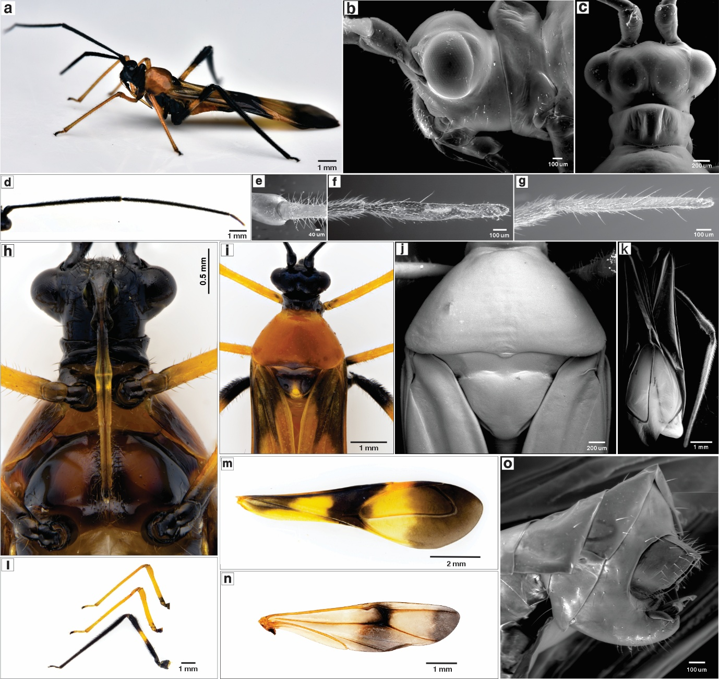
Figure 6. Morphological characters of M. dissimulatum. (a) Live adult in lateral view. (b) Lateral view of the head. (c) Dorsal view of the head. (d) Antenna showing four visible segments. (e) Detail of the junction between the antennal scape and pedicel. (f) Terminal antennal segment of the male. (g) Terminal antennal segment of the female. (h) Rostrum with four segments. (i) Dorsal view of the pronotum and posterior margin of the scutellum. (j) Dorsal view of the scutellum. (k) Dorsal view of the hemelytra. (l) Legs showing the characteristic coloration and yellow band on the middle portion of the hind femora. (m) Forewings. (n) Hind wings. (o) Female terminalia.
Diagnostic characters. Taxonomic recognition of adults was based on the combination of the dark coloration of the head and antennae, the cervical constriction of the pronotum, the color pattern of the scutellum and hemelytra, and the distribution of pigmentation on the legs, particularly the hind legs. These attributes were evaluated in conjunction with the morphometric proportions (Table 2), rather than being considered as isolated diagnostic traits.
Adult morphometrics. Females were larger than males for most of the variables evaluated (Table 2). The most pronounced differences were observed in total body length (12.89 ± 0.38 mm in females vs. 10.59 ± 0.39 mm in males), hemelytron length (10.00 ± 0.26 mm vs. 8.23 ± 0.27 mm), and cuneus length (2.34 ± 0.12 mm vs. 1.55 ± 0.14 mm), as well as in the dimensions of the hind leg. In contrast, vertex width, antennomere IV length, and tarsal length showed similar values between the sexes.
Table 2. Morphometrics of adult female and male Monalonion dissimulatum.
Region | Variable | Female: Mean ± SD (Range), mm | Male: Mean ± SD (Range), mm
Body | Body length | 12.89 ± 0.38 (11.78–13.66) | 10.59 ± 0.39 (9.48–11.10)
 | Body width | 2.44 ± 0.11 (2.26–2.67) | 2.15 ± 0.11 (1.99–2.40)
Head | Head length | 0.98 ± 0.06 (0.81–1.07) | 0.87 ± 0.04 (0.79–0.93)
 | Head width | 1.66 ± 0.04 (1.56–1.73) | 1.47 ± 0.04 (1.41–1.53)
 | Vertex width | 0.85 ± 0.03 (0.79–0.93) | 0.82 ± 0.06 (0.73–0.95)
Antenna | Antennomere I length | 0.39 ± 0.05 (0.30–0.47) | 0.36 ± 0.04 (0.26–0.44)
 | Antennomere II length | 4.53 ± 0.13 (4.19–4.81) | 3.84 ± 0.19 (3.50–4.22)
 | Antennomere III length | 4.32 ± 0.11 (4.16–4.56) | 3.99 ± 0.14 (3.68–4.20)
 | Antennomere IV length | 1.00 ± 0.10 (0.82–1.19) | 0.99 ± 0.07 (0.84–1.10)
Pronotum | Pronotum length | 1.48 ± 0.05 (1.36–1.56) | 1.24 ± 0.09 (1.08–1.42)
 | Pronotum base width | 1.00 ± 0.06 (0.87–1.12) | 0.91 ± 0.06 (0.77–0.99)
Hemelytron | Hemelytron length | 10.00 ± 0.26 (9.40–10.50) | 8.23 ± 0.27 (7.65–8.74)
 | Cuneus length | 2.34 ± 0.12 (2.15–2.58) | 1.55 ± 0.14 (1.29–1.94)
 | Cuneus base width | 0.50 ± 0.04 (0.42–0.57) | 0.43 ± 0.06 (0.31–0.53)
Foreleg | Fore femur length | 2.44 ± 0.09 (2.26–2.59) | 2.26 ± 0.07 (2.10–2.36)
 | Fore tibia length | 3.59 ± 0.08 (3.38–3.73) | 3.29 ± 0.10 (3.09–3.49)
 | Fore tarsus length | 0.69 ± 0.04 (0.63–0.76) | 0.66 ± 0.03 (0.61–0.73)
Midleg | Mid femur length | 2.51 ± 0.06 (2.38–2.61) | 2.34 ± 0.18 (1.97–2.70)
 | Mid tibia length | 3.45 ± 0.35 (2.76–4.00) | 3.28 ± 0.19 (2.86–3.53)
 | Mid tarsus length | 0.70 ± 0.05 (0.60–0.83) | 0.67 ± 0.02 (0.62–0.70)
Hindleg | Hind femur length | 3.57 ± 0.14 (3.20–3.79) | 2.96 ± 0.21 (2.50–3.32)
 | Hind tibia length | 5.79 ± 0.19 (5.44–6.29) | 4.88 ± 0.23 (4.50–5.33)
 | Hind tarsus length | 0.72 ± 0.04 (0.66–0.79) | 0.65 ± 0.04 (0.58–0.75)

Molecular identification and phylogenetic analysis
Consensus COI gene sequences of 673, 672, and 646 bp were obtained for specimens LES54, LES58, and LES59, respectively. The chromatograms showed high read quality, with no ambiguous sites in the final sequences, and multiple sequence alignment with the reference sequences revealed no insertions or deletions.
The query against BOLD Systems revealed 100% identity with record TRBBO262-11, corresponding to M. dissimulatum, supporting the morphological identification of the specimens. Likewise, the phylogenetic analysis inferred under the maximum likelihood (ML) criterion showed that the LES54, LES58, and LES59 sequences clustered with the reference sequence of M. dissimulatum. This topology was consistent with both the DNA barcode results and the morphological diagnosis (Figure 7).
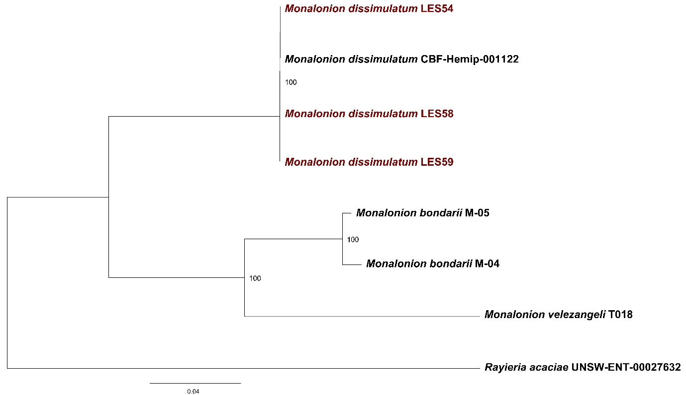
Figure 7. Phylogenetic tree based on the COI gene, reconstructed using maximum likelihood (RAxML) with 1,000 bootstrap replicates. The LES54, LES58, and LES59 sequences (in red) cluster with the reference sequence TRBBO262-11 (M. dissimulatum), and Rayieria acaciae was used as the outgroup.

Life cycle
The life cycle of M. dissimulatum under field conditions lasted a total of 34–46 days, comprising the egg stage, five nymphal instars, and the adult stage. The incubation period ranged from 6 to 10 days (7.89 ± 1.03 days). The duration of the nymphal instars was relatively uniform (mean: 4.49–4.63 days), with total nymphal development lasting 20–26 days. Adult longevity ranged from 8 to 10 days (9.11 ± 0.57 days) (Table 3).
Table 3. Duration (days) of the biological cycle of M. dissimulatum
Developmental stage | Mean ± SD (days) | Range (days)
Egg | 7.89 ± 1.03 | 6–10
Nymph I | 4.63 ± 0.53 | 4–6
Nymph II | 4.59 ± 0.50 | 4–5
Nymph III | 4.50 ± 0.51 | 4–5
Nymph IV | 4.49 ± 0.51 | 4–5
Nymph V | 4.50 ± 0.51 | 4–5
Adult | 9.11 ± 0.57 | 8–10
Total life cycle |  | 34-46

DISCUSSION
Tissue lesions induced by the feeding activity of M. dissimulatum mainly affect young organs and developing fruits (Huaycho Callisaya et al. 2017; Gamboa et al. 2024). Under the conditions evaluated, the lesions progressed into coalescent, crust-like necrotic areas on the pericarp, causing deformation and deterioration in severely affected fruits. This pattern is consistent with previous reports in Monalonion, which describe the progression of damage toward necrotic areas accompanied by tissue suberization; under severe infestations, damage to young fruits may impair their development and cause premature death (Giraldo-Jaramillo et al. 2010; Huaycho Callisaya et al. 2017; Babin 2018; Gamboa et al. 2024). The importance of this fruit-level damage becomes more evident when incidence is considered at the plot scale.
The incidence of phytophagous insects in agroecosystems is influenced by the interaction of biotic and abiotic factors that vary along environmental gradients (Körner 2007; Asitoakor et al. 2024). The positive correlation between elevation and the incidence of M. dissimulatum observed in this study suggests that pest incidence may be associated with ecological conditions that vary along the elevational gradient. However, elevation explained only 38.5% of the observed variability, indicating that its effect should not be interpreted in isolation, because multiple environmental variables may change simultaneously along elevational gradients (Andrew et al. 2012; Moreira et al. 2018; Dostálek et al. 2018; Paudel et al. 2021). Given that the plots were subjected to broadly similar management conditions, the unexplained variation may be associated with microclimatic and structural differences among sites, such as temperature, humidity, and canopy characteristics, factors that have been shown to influence mirid abundance and infestation in cacao production systems (Vargas et al. 2005; Asitoakor et al. 2024); however, these variables were not quantified in the present study.
All Monalonion specimens collected from cacao at the evaluated sites represented a single morphotype, consistent with the description of M. dissimulatum (Distant 1883; Carvalho 1972; Gamboa et al. 2020). The immature stages constituted a continuous ontogenetic series of five instars, differentiated mainly by the progressive increase in body size. the development of wing pads, and changes in dorsal pigmentation. Although this pattern is shared with other species of the genus, differences were observed in the pigmentation of the dorsum, antennae, and legs, as well as in body dimensions, with later instars being larger than those of M. velezangeli (Giraldo-Jaramillo et al. 2010). In adults, identification could be supported by a broader set of diagnostic characters, particularly those related to coloration, pronotal configuration, the hemelytra, and the pigmentation pattern of the legs.
The morphology of the adults examined showed overall agreement with the original description of M. dissimulatum and with subsequent taxonomic characterizations of the species (Distant 1883; Carvalho 1972; Gamboa et al. 2020). In particular, the dark coloration of the head and antennae, the configuration of the pronotum, the presence of a dark fascia on the corium, and the contrasting pigmentation pattern of the hind legs were consistent with characters historically attributed to the species. Nevertheless, differences were observed in some coloration characters. Whereas (Distant 1883) described the apex of the scutellum as black, the specimens from Amazonas showed dark lateral areas contrasting with a yellowish central region; likewise, the pronotum was predominantly yellowish orange. These differences may fall within the intraspecific variability documented for the genus and, together with the overlap of characters among species, highlight the limitations of identification based on isolated morphological traits (Gamboa et al. 2020).
In the present study, molecular characterization using the COI marker was employed as a complement to morphological identification. The three sequences obtained showed 100% identity with the reference record and clustered with M. dissimulatum in the phylogenetic analysis, thereby supporting the identification based on morphological characters. The COI gene is a widely used tool for supporting species identification and has proven useful in Miridae, particularly when integrated with morphological evidence (Hebert et al. 2003; Kim and Jung 2018). In Monalonion, this integrative approach has also recently been used to support the identification of M. velezangeli in Ecuador and Peru (Noboa et al. 2024; Leiva-Espinoza et al. 2026). However, the scope of the molecular evidence in the present study is limited by the small number of sequenced specimens and by the availability of reference sequences for the genus. Therefore, these results should be interpreted as complementary evidence supporting the morphological identification rather than as a comprehensive assessment of the species’ molecular variability.
The observed life cycle was consistent with the paurometabolous pattern previously described for the species, characterized by five nymphal instars before reaching the adult stage (Vargas Serna et al. 2020). The observed duration was also within the range reported for Monalonion species under tropical conditions, although differences among studies may be associated with the environmental and local conditions under which the populations develop (A. Villacorta 1977; Giraldo-Jaramillo et al. 2010; Gamboa et al. 2024). Given that the available biological information for M. dissimulatum comes from specific localities and environmental conditions, characterization of its development under the production conditions of Amazonas provides reference information for understanding its local dynamics and guiding its monitoring and management.
The taxonomic assignment of the specimens to M. dissimulatum was supported by an integrative approach based on the congruence of morphological, molecular, and biological evidence, strengthening recognition of the species in the evaluated cacao production systems. From a phytosanitary perspective, the relatively short life cycle observed suggests rapid generational turnover under favorable conditions, while the damage recorded on young tissues and developing fruits highlights its importance for cacao production. In addition, feeding-induced lesions may compromise pericarp integrity and potentially facilitate secondary infection processes (Bailey et al. 2018; Gossner et al. 2021). Therefore, these results underscore the importance of accurate taxonomic identification and knowledge of the species’ biology for guiding monitoring and integrated management strategies.

CONCLUSION
Monalonion dissimulatum caused characteristic damage to cacao fruits, evidenced by the formation of coalescent necrotic lesions on the pericarp, which under high levels of damage progressed to fruit deformation and tissue desiccation. Pest incidence showed a positive correlation with elevation, although this variable explained only part of the observed variability, indicating the possible contribution of other unmeasured environmental factors. Morphological characterization of nymphs and adults allowed the recognition of a set of characters consistent with M. dissimulatum, although the observed coloration variation highlights the limitations of identification based exclusively on external traits; molecular evidence based on the COI marker was consistent with this taxonomic assignment. The three sequenced specimens showed 100% identity with the reference record and phylogenetic clustering consistent with M. dissimulatum. Likewise, the life cycle comprised an egg stage, five nymphal instars, and the adult stage, with a total duration of 34–46 days under field conditions. These results provide a scientific basis for understanding the damage, incidence, identification, and biology of M. dissimulatum in cacao production systems in Amazonas and establish a reference framework for its recognition, monitoring, and management in the region.
Statements and Declarations
Author Contributions
Conceptualization: S.T.L.E., L.A.C.V., J.A.V.C.; Data curation: S.T.L.E., H.W.S.C., V.A.R., J.A.V.C.; Formal analysis: S.T.L.E., H.W.S.C., V.A.R., J.A.V.C.; Funding acquisition: S.T.L.E., G.F.R.D., J.A.V.C.; Investigation: S.T.L.E., H.W.S.C., G.F.R.D., D.B.M., V.A.R., E.R.R.R., L.A.C.V., J.A.V.C.; Methodology: S.T.L.E., H.W.S.C., L.A.C.V., J.A.V.C.; Project administration: S.T.L.E., L.A.C.V.; Resources: S.T.L.E., H.W.S.C., G.F.R.D., D.B.M., V.A.R., E.R.R.R., L.A.C.V., J.A.V.C.; Software: S.T.L.E., H.W.S.C., V.A.R., J.A.V.C.; Supervision: S.T.L.E., H.W.S.C., G.F.R.D., V.A.R., L.A.C.V., J.A.V.C.; Validation: S.T.L.E., H.W.S.C., G.F.R.D., D.B.M., V.A.R., E.R.R.R., L.A.C.V., J.A.V.C.; Visualization: S.T.L.E., H.W.S.C., D.B.M., V.A.R., E.R.R.R., L.A.C.V.; Writing – original draft: S.T.L.E., H.W.S.C., G.F.R.D., D.B.M., V.A.R., E.R.R.R., L.A.C.V., J.A.V.C.; Writing – review & editing: S.T.L.E., H.W.S.C., G.F.R.D., D.B.M., V.A.R., E.R.R.R., L.A.C.V., J.A.V.C. All authors approved the final version of the manuscript.

Funding
This study was conducted within the framework of the project “Creation of the Science, Technology, and Technological Innovation Promotion Service at the Research Center for Integrated Pest and Disease Management ‘CEMIPE’ of the Universidad Nacional Toribio Rodríguez de Mendoza de Amazonas” (CUI 2671977). The authors also thank the Vice-Rectorate for Research of the Universidad Nacional Toribio Rodríguez de Mendoza de Amazonas for the financial support provided to cover the article processing charge (APC).
Competing Interests
The authors declare no conflicts of interest
Data Availability
The data and analysis code supporting the findings of this study are openly available in Zenodo at https://doi.org/10.5281/zenodo.23091015. The associated GitHub repository is available at https://github.com/henrysantillan/monalonion-dissimulatum-study.
Acknowledgements
The authors thank the Plant Health Laboratory of the Instituto de Investigación para el Desarrollo Sustentable de Ceja de Selva (INDES-CES).
References
A. Villacorta (1977) Algunas observaciones sobre la biologia de Monalonion annulipes Sig. en Costa Rica. An Soc Entomológica Bras 6:173–179. https://doi.org/10.37486/0301-8059.v6i2.111
Andrew NR, Roberts IR, Hill SJ (2012) Insect herbivory along environmental gradients. Open J Ecol 02:202–213. https://doi.org/10.4236/oje.2012.24024
Asitoakor BK, Ræbild A, Asare R, et al (2024) The potential of selected shade tree species for managing mirids and black pod disease infection in cocoa agroforestry systems in Ghana. Crop Prot 184:106810. https://doi.org/10.1016/j.cropro.2024.106810
Babin R (2018) Pest management in organic cacao. In: Vacante V, Kreiter S (eds) Handbook of pest management in organic farming, 1st edn. CAB International, UK, pp 502–518
Bailey BA, Evans HC, Phillips‐Mora W, et al (2018) Moniliophthora roreri , causal agent of cacao frosty pod rot. Mol Plant Pathol 19:1580–1594. https://doi.org/10.1111/mpp.12648
Beg MS, Ahmad S, Jan K, Bashir K (2017) Status, supply chain and processing of cocoa - A review. Trends Food Sci Technol 66:108–116. https://doi.org/10.1016/j.tifs.2017.06.007
Carvalho JC de M (1972) Mirídeos neotropicais, CXLVI: Gênero Monalonion H.-S., 1853 (Hemiptera). An Acad Bras Ciênc 44:119–143
Carvalho JC de M (1984) Mirideos Neotropicales, CCXLIII: Nuevas especies de la República de Colombia (Hemiptera). Rev Gallescencia 1:11–20
Carvalho JC de M (1985a) Mirídios neotropicais: CCLV: descrições de cinco espécies novas e revalidação de Monalonion decoratum Monte (Hemiptera). Rev Bras Zool 3:. https://doi.org/10.1590/S0101-81751985000400002
Carvalho JC de M (1985b) Mirídeos Neotropicais, CCLXII: Descrições de um gênero e onze espécies novas da América Central e América do Sul (Hemiptera). Rev Bras Biol 45:653–668
Carvalho JC de M (1988) Mirídeos neotropicais, CCLXXX: duas espécies novas do gênero Neoleucon Distant e nota taxonômica sobre Monalonion peruvianus Kirkaldy (Hemiptera). Rev Bras Entomol 32:175–178
Carvalho JC de M, Costa LAA (1988) Mirídeos neotropicais, CCXCVII: duas novas espécies do gênero Monalonion Herrich-Schaeffer (Hemiptera). Rev Bras Biol 48:
Cochran WG (1977) Sampling Techniques, 3rd edn. John Wiley & Sons, New York
Distant WL (1883) Insecta. Rhynchota. Hemiptera-Heteroptera. In: Biologia Centrali-Americana. London, pp 225–264
Dostálek T, Rokaya MB, Münzbergová Z (2018) Altitude, habitat type and herbivore damage interact in their effects on plant population dynamics. PLOS ONE 13:e0209149. https://doi.org/10.1371/journal.pone.0209149
Gamboa J, Pérez-Benavides L, Ospina-Peñuela E, et al (2024) A new species of Uscanoidea Girault (Hymenoptera, Trichogrammatidae), an egg parasitoid of Monalonion dissimulatum Distant (Hemiptera, Miridae). J Hymenopt Res 97:191–206. https://doi.org/10.3897/jhr.97.111008
Gamboa J, Serna F, Morales I (2020) Estado actual del conocimiento taxonómico del género Monalonion Herrich-Schaeffer, 1850 (Hemiptera: Heteroptera: Miridae: Bryocorinae: Monaloniini). Bol Científico Cent Mus Mus Hist Nat 24:144–168. https://doi.org/10.17151/bccm.2020.24.2.11
Giraldo-Jaramillo M, Benavides-Machado P, Villegas-García C (2010) Aspectos morfológicos y biológicos de Monalonion velezangeli Carvalho & Costa (Hemiptera: Miridae) en café. Cenicafé 61:195–205
Gossner MM, Beenken L, Arend K, et al (2021) Insect herbivory facilitates the establishment of an invasive plant pathogen. ISME Commun 1:6. https://doi.org/10.1038/s43705-021-00004-4
Gutierrez Soto CA, Sánchez Castillo V (2024) Local methods for the control of Monalonion dissimulatun pest in cacao farms in Florencia- Caquetá. SAP Multidiscip Open 2:83. https://doi.org/10.62486/mo202483
Hebert PDN, Cywinska A, Ball SL, deWaard JR (2003) Biological identifications through DNA barcodes. Proc R Soc Lond B Biol Sci 270:313–321. https://doi.org/10.1098/rspb.2002.2218
Hernández-Núñez HE, Gutiérrez-Montes I, Sánchez-Acosta JR, et al (2020) Agronomic conditions of cacao cultivation: its relationship with the capitals endowment of Colombian rural households. Agrofor Syst 94:2367–2380. https://doi.org/10.1007/s10457-020-00556-9
Huaycho Callisaya H, Maldonado Fuentes C, Manzaneda Delgado F (2017) Control del chinche del cacao (Monaloniondis simulatum Dist.) con aplicación de bioinsecticidas en la región de los Yungas de Bolivia. Rev Investig E Innov Agropecu Recur Nat 4:31–39
Kim J, Jung S (2018) COI barcoding of plant bugs (Insecta: Hemiptera: Miridae). PeerJ 6:e6070. https://doi.org/10.7717/peerj.6070
Kongor JE, Owusu M, Oduro-Yeboah C (2024) Cocoa production in the 2020s: challenges and solutions. CABI Agric Biosci 102. https://doi.org/10.1186/s43170-024-00310-6
Körner C (2007) The use of ‘altitude’ in ecological research. Trends Ecol Evol 22:569–574. https://doi.org/10.1016/j.tree.2007.09.006
Kumar S, Stecher G, Li M, et al (2018) MEGA X: Molecular Evolutionary Genetics Analysis across Computing Platforms. Mol Biol Evol 35:1547–1549. https://doi.org/10.1093/molbev/msy096
Leiva-Espinoza ST, Aguilar V, Banda-Martinez D, et al (2026) First report of Monalonion velezangeli (Hemiptera: Miridae) damaging avocado (Persea americana) in Peru. Phytoparasitica 54:50. https://doi.org/10.1007/s12600-026-01384-w
Marelli J-P, Guest DI, Bailey BA, et al (2019) Chocolate Under Threat from Old and New Cacao Diseases. Phytopathology® 109:1331–1343. https://doi.org/10.1094/PHYTO-12-18-0477-RVW
Moreira X, Petry WK, Mooney KA, et al (2018) Elevational gradients in plant defences and insect herbivory: recent advances in the field and prospects for future research. Ecography 41:1485–1496. https://doi.org/10.1111/ecog.03184
Namyatova AA, Cassis G (2016) Systematic revision and phylogeny of the plant bug tribe Monaloniini (Insecta: Heteroptera: Miridae: Bryocorinae) of the world: Systematics of the Tribe Monaloniini. Zool J Linn Soc 176:36–136. https://doi.org/10.1111/zoj.12311
Noboa M, Castillo C, Carvajal V, et al (2024) First record of Monalonion velezangeli (Hemiptera: Miridae) affecting avocado and cherimoya (Annona cherimola) as new hosts in Ecuador. Zootaxa 5519:423–429. https://doi.org/10.11646/zootaxa.5519.3.5
Paudel S, Kandel P, Bhatta D, et al (2021) Insect Herbivore Populations and Plant Damage Increase at Higher Elevations. Insects 12:1129. https://doi.org/10.3390/insects12121129
R Core Team, 2026 R: A Language and Environment for Statistical Computing
Tan H, Lou Y, Yan Y, et al (2025) Near T2T haplotype-resolved genomes of cacao (Theobroma cacao) variety CCN51. Sci Data 13:163. https://doi.org/10.1038/s41597-025-06480-w
Vargas A, Somarriba E, Carballo M (2005) inámica poblacional del chinche (Monalonion dissimulatum Dist.) y daño de mazorcas en plantaciones orgánicas de cacao del Alto Beni, Bolivia. Agroforestería En Las Américas 72–76
Vargas Serna E, Vargas Serna D, Chuyma Tomaylla M, et al (2020) EFECTO DEL EXTRACTO ACUOSO DE Clibadium surinamense L. EN EL CONTROL DE Monalonion dissimulatum Dist. EN UNA PLANTACIÓN DE CACAO (Theobroma cacao L.). Folia Amaz 28:217–225. https://doi.org/10.24841/fa.v28i2.484

